# Power Up Challenge Requirements

Business scenarios (Animal Shelter)

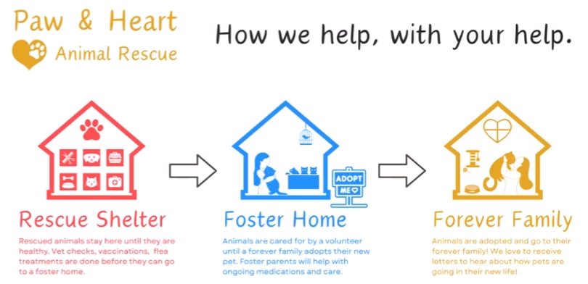

Paw & Heart is an animal rescue charity that operates animal shelters and liaises with local families to foster animals. The goal is to help every pet to get the veterinary care they need and to find their forever home.

The organization aims to:

* Improve record-keeping on animals staying at their shelter and foster homes.
* Make it easier for foster or adoption families to provide support.
* Provide the social media team with insightful reports to help them encourage more people to foster or adopt a pet.

Overview

* Mandatory Requirements for successful completion of the course
* Apply your knowledge and skills acquired during this course.
* Requirements span across
  + Dataverse
  + Power Apps (Model-driven app & Canvas Apps)
  + Power Automate cloud flows.
  + Power BI reports

High-Level uses-cases

1. Create Dataverse tables and load available shelter data.
   1. Persona: Shelter Staff
   2. Use Case: To effectively manage all shelter data in one place.
   3. Create data structure & import the shelter data provided in the Power Up Challenge resources.
      1. Animal Data
      2. Shelter Locations
      3. Foster family information
2. Create a model-driven app listing all the animals in the shelter and their details.
   1. Persona: Shelter Staff
   2. User Case: To effectively manage all shelter operations.
   3. View a list of animals displaying name, type, shelter status and location.
   4. Ability to sort and filter the animal list by type or animal and by shelter status.
   5. Ability to select an animal and see animal details such as name, type, age, sex, shelter status, location, medical issues, and upcoming veterinary appointments.
   6. Ability to update the details for an animal such as medical issues, veterinary information, and mark an animal as ‘ready to foster’ one they have passed their medical requirements.
   7. Authentication for shelter staff, foster family and marketing teams is not required. (maybe do as a bonus)
3. Create a canvas app listing all animals available for fostering or adoption and their details.
   1. Persona: Foster family
   2. Use Case: to facilitate choosing an animal to foster.
   3. View a list of animals at their local shelter that are ready to be fostered, featuring name, type, age, picture, and any medical conditions.
   4. Ability to select an animal, enter foster family information and update the status to ‘claimed for foster’ on click of a button and the family that the animal is associated with.
4. Send Power Automation notification containing fostering process details.
   1. Persona: Foster Family
   2. Use Case: to advise the foster family on next steps.
   3. When an animal’s status changes to ‘claimed for foster’, send a notification email* to the foster family indicating details associated with the animal and a date to arrange to come and pick up the animal.
   4. Send/Receive emails using your personal email address.
5. Create a Power BI data visualization dashboard.
   1. Persona: Marketing Team
   2. Use Case: To showcase shelter accomplishments.
   3. Latest News (In last 1 months)
      1. Number of pets who arrived at the shelter.
      2. Number of pets that were fostered.
   4. Trends (In last 3 months)
      1. Most rescued type of animal.
      2. Most fostered type of animals.

Submission

To submit your Power Up Challenge, you will need to create a video demonstrating the various features of your solution that address the various challenge requirements:

Video requirements:

* Must in .mp4 file format
* Must be 10 minutes or less in duration.
* Must be under 100MB in file size.
* Must feature your narration (voice over) and explaining the solution.

Submit your video under the Power Up Challenge.

Analytics Report